PROJECT DEMONSTRATION GUIDE
Automated Network Request Management in ServiceNow
Project Name | Automated Network Request Management in ServiceNow
Prepared By
Platform | ServiceNow
Document Type | Final Project Demonstration
Demo Scope | Network Request Submission to Approval / Fulfilment Tracking
Date | 02 October 2026
1. DEMONSTRATION PURPOSE
This document defines the final demonstration flow for the Automated Network Request Management in ServiceNow project. The demonstration is intended to show the complete requester-to-approval workflow: opening the ServiceNow portal, submitting a Network Request, creating the REQ/RITM, retrieving catalog variables, creating the operational Database Tables record, requesting approval, following the approved/rejected decision path, sending notifications, tracking the request and reviewing operational access.
• Demonstrate the requester-facing Network Request catalog experience.
• Show the automated ServiceNow workflow behind the request.
• Prove that submitted catalog values are stored in the configured Database Tables (u_database_tables) record.
• Demonstrate approval processing and decision-based branching.
• Show request tracking through REQ/RITM and lifecycle stages.
• Demonstrate requester, approver, operational/fulfilment and administrator perspectives.
• Explain the major configuration/debugging issues faced during development and how they were resolved.
2. DEMONSTRATION ARCHITECTURE
The live demonstration should follow the implemented architectural path:
Requester → ServiceNow Service Portal → Networks and Connectivity → Network Request Catalog Item → Catalog Variables / UI Policy → Flow Designer → REQ/RITM + Database Tables (u_database_tables) → Ask for Approval → Approved / Rejected Branch → Update Record → Email Notification → Request Tracking / Fulfilment.
The demonstration should also show the security and diagnostics layer: Roles + ACLs protect operational data, the Approval Request relationship connects approval records to the operational record, and Flow Designer Execution Details provide execution traceability.
REQUESTER | SERVICE NOW PORTAL | NETWORK REQUEST | FLOW DESIGNER | APPROVAL
Catalog form | Variables / UI Policy | REQ / RITM | Database Tables | Approved / Rejected
Tracking | Notifications | Roles + ACLs | Approval Relationship | Execution Details
3. DEMO PREREQUISITES
Requirement | Demo Readiness Check
ServiceNow Instance | PDI or authorized project instance is active and accessible.
Requester Account | User can open Service Portal and submit the Network Request catalog item.
Approver Account | Authorized account can access and process the configured approval.
Administrator / Operations Account | Authorized account can inspect Flow Designer, Database Tables, ACLs and execution details.
Catalog Item | Network Request is active and accessible under Networks and Connectivity.
Sample Request Data | Prepare one complete set of valid requester, connection, address and reference values.
Notification Configuration | Configured request-created and approved/resolved email actions are available.
Browser | Use a clean browser session; keep requester and admin/approver views in separate tabs or profiles.
4. FINAL LIVE DEMONSTRATION FLOW
Step | Demo Action | Role | What to Show | Expected Result
Step 1 | Open ServiceNow Service Portal | Requester | Open portal home page and navigate to Networks and Connectivity. | Portal loads and Network Request service is visible.
Step 2 | Open Network Request | Requester | Open the Network Request catalog item and point out the configured fields. | Configured catalog variables are visible and usable.
Step 3 | Enter Request Details | Requester | Enter Requested For, Mobile Number, Type of Connection, Existing ID when applicable, Total Amount, Mode of Payment, Address, Database Number and Request Number. | Form accepts valid values and configured UI Policy behaviour works.
Step 4 | Submit Request | Requester | Submit the completed catalog request and show confirmation/reference. | REQ/RITM is created and Flow Designer starts processing.
Step 5 | Show Catalog Variable Retrieval | Administrator / Operations | Open the Network Request flow and show Get Catalog Variables. | Configured request variables are available to downstream actions.
Step 6 | Show Operational Record | Administrator / Operations | Open Database Tables and locate the record created from the request. | Catalog values are mapped to the configured operational fields.
Step 7 | Show Approval | Approver / Administrator | Open the approval request and show the approval action/status. | Approval is generated and can be approved or rejected.
Step 8 | Show Decision Branch | Administrator | Open Flow Designer Execution Details and show the Approved or alternate branch. | Correct condition path executes and Approval Status is updated.
Step 9 | Show Notification | Requester / Administrator | Show the request-created or approved/resolved email action/result. | Configured notification action executes for the relevant path.
Step 10 | Track Request Status | Requester | Open the request/RITM and show lifecycle/status information. | Requester can identify the current request state.
Step 11 | Operational / Fulfilment View | Operations | Switch to authorized operational view and inspect the request record. | Authorized user can access relevant operational data.
Step 12 | End-to-End Validation | All relevant roles | Summarize Request → RITM → Record → Approval → Decision → Update → Notification → Tracking. | Complete workflow is demonstrated without an unresolved blocking defect.
4.1 Suggested Narration During the Live Demo
Step 1 - Open ServiceNow Service Portal: “I will begin from the requester side. The user accesses the ServiceNow portal and selects the Network Request service.”
Step 2 - Open Network Request: “The form captures the structured information required to process the network request.”
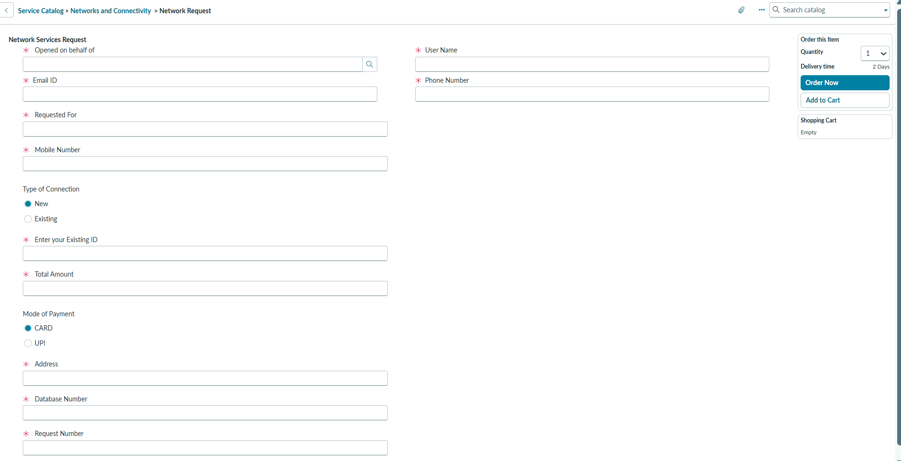
Figure 1. Network Request catalog form before data entry.
Evidence: shows the requester-facing Network Services Request form and its configured fields.
Step 3 - Enter Request Details: “The catalog variables and UI Policy control the request form and its configured dynamic behaviour.”
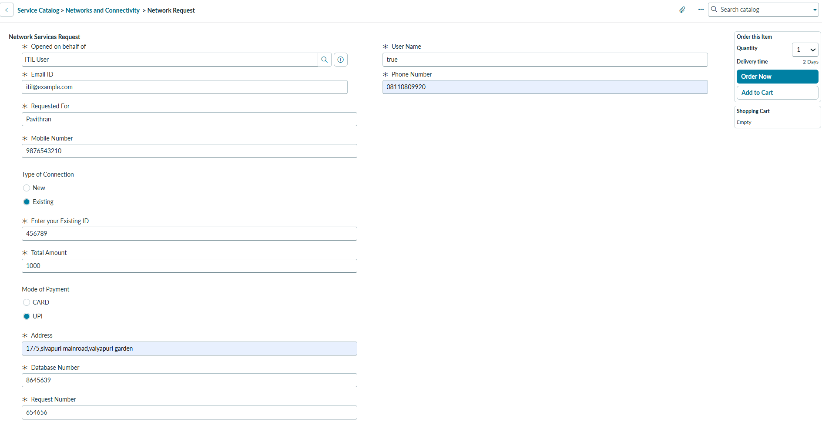
Figure 2. Network Request form with submitted sample values.
Evidence: demonstrates populated requester, connection, payment, address, database and request fields.
Step 4 - Submit Request: “Once submitted, ServiceNow creates the request and requested item, and the automation takes over.”
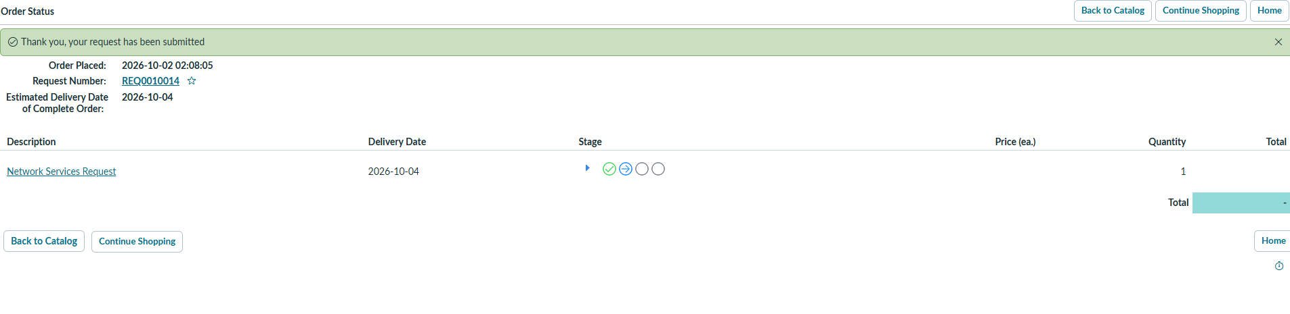
Figure 3. ServiceNow Order Status after request submission.
Evidence: confirms successful submission and generated request number REQ0010014 with the displayed delivery date.
Step 5 - Show Catalog Variable Retrieval: “Flow Designer retrieves the submitted catalog values so they can be used by downstream actions.”
Step 6 - Show Operational Record: “The submitted values are mapped into the configured Database Tables operational record for structured processing.”
Step 7 - Show Approval: “The workflow requests approval so the decision remains controlled by the authorized approver.”
Step 8 - Show Decision Branch: “The flow evaluates the approval result and follows the corresponding update path.”
Step 9 - Show Notification: “The configured email action communicates the relevant request outcome.”
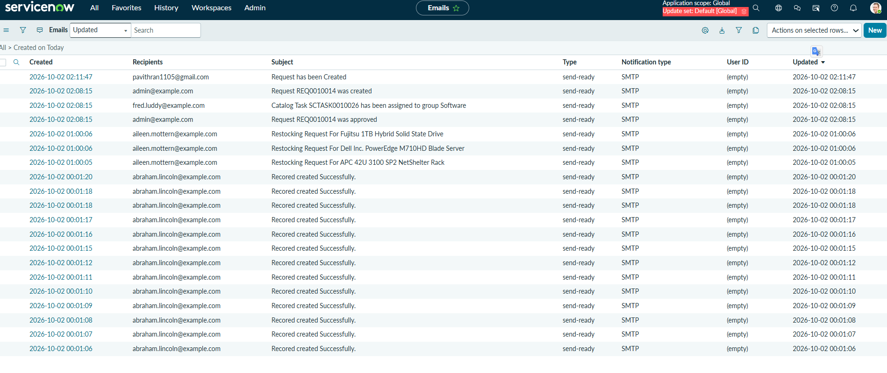
Figure 6. ServiceNow email list showing request-related notifications.
Evidence: shows generated email records, including the 'Request has been Created' notification.
Step 10 - Track Request Status: “The requester can follow the REQ/RITM lifecycle instead of losing visibility after submission.”
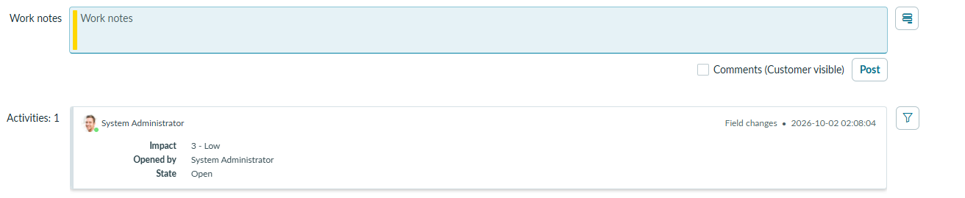
Figure 4. Request activity / work-notes view.
Evidence: shows the operational request record activity area and current request state.
Step 11 - Operational View: “Authorized operational users can review the data needed for fulfilment while ACLs control access.”
Step 12 - End-to-End Validation: “This completes the journey from request submission through approval, update, notification and tracking.”
5. ROLE-BASED DEMONSTRATION
Role | Key Demo Activities | Main Components
Requester | Open catalog item; enter request details; submit request; track REQ/RITM; review status/notifications. | Service Portal, Service Catalog, catalog variables, REQ/RITM
Approver | Review the submitted request and approve/reject according to the configured process. | Approval record, Ask for Approval, approval status
Network Fulfilment / Operations | Review authorized operational record and use request data for fulfilment. | Database Tables, request/RITM data, roles/ACLs
ServiceNow Administrator | Configure and demonstrate Flow Designer, table, ACLs, relationship, notifications and troubleshooting. | Flow Designer, Execution Details, tables, ACLs, Approval Request relationship
6. PROBLEMS FACED AND LIVE EXPLANATION
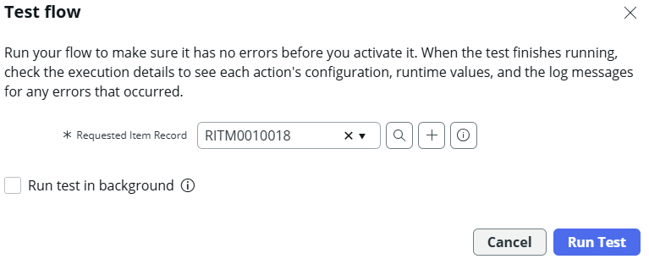
Figure 5. Flow Designer test-flow dialog for RITM0010018.
Evidence: demonstrates test execution setup for the submitted requested item before reviewing execution details and runtime logs.
Problem | What Happened | Resolution | How to Demonstrate
Approval / Approver Visibility | Approval context and approver visibility required configuration validation. | Validated Ask for Approval configuration and the Approval Request relationship against the operational record. | Open the approval/relationship view and explain how the approval is connected to the request.
Variable-to-Field Mapping | Some submitted catalog values required correction or verification before being stored correctly. | Corrected and verified catalog-variable retrieval and data-pill/field mappings. | Compare submitted catalog values with the Database Tables record.
Flow Execution Path | Actions/conditions required validation during workflow configuration. | Used Flow Designer Execution Details to identify action/condition issues and verify the corrected path. | Open a successful execution and point out the action sequence.
Portal/Form Behaviour | Conditional field visibility required portal-specific validation. | Validated the Catalog UI Policy behaviour in the catalog experience. | Change the relevant form value and show the configured field behaviour.
Request Lifecycle Validation | The full progression from request creation through approval and fulfilment stages required end-to-end verification. | Validated REQ/RITM creation, approval status and lifecycle evidence. | Show the request/RITM and the corresponding workflow state.
7. DEMONSTRATION EVIDENCE / SCREENSHOTS
Notification Evidence
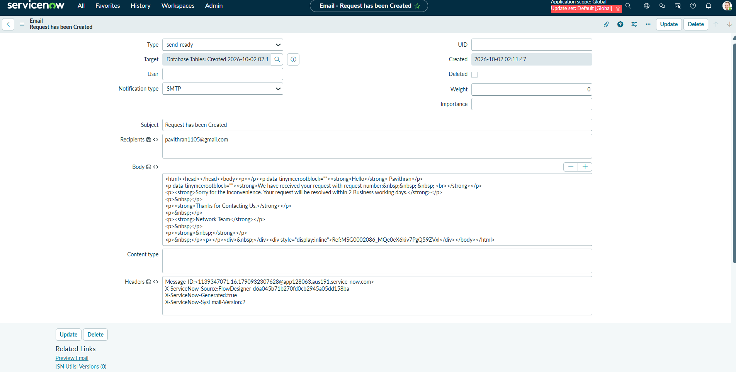
Figure 7. Email record for 'Request has been Created'.
Evidence: shows the generated email subject, recipient, target record and message body.
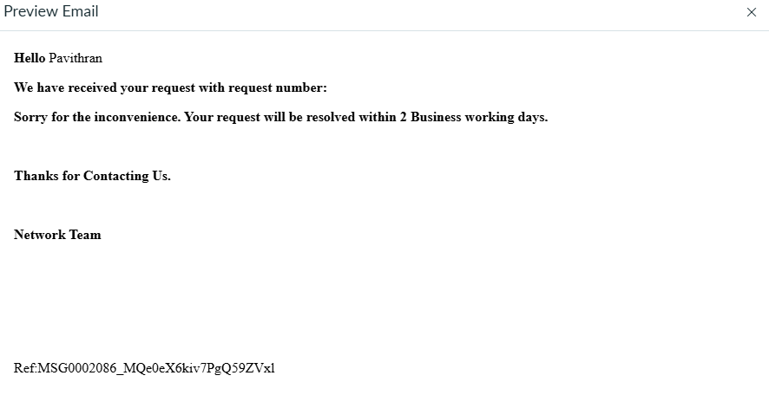
Figure 8. Preview of the request-created email.
Evidence: shows the requester-facing notification content and the stated two-business-day resolution message.
Use the actual project screenshots during the live presentation. The recommended evidence sequence is:
• Network Request catalog item under Networks and Connectivity.
• Network Request form showing the configured variables and dynamic field behaviour.
• Submitted request showing REQ/RITM reference.
• Flow Designer Network Request flow showing Get Catalog Variables, Create Database Tables Record, Send Email, Ask for Approval and the decision branches.
• Database Tables record showing mapped request values.
• Approval record / Approval Request relationship.
• Flow Designer Execution Details for the submitted request.
• Request lifecycle/status view showing the current stage.
• Notification evidence for request creation or approved/resolved outcome.
• Authorized operational view showing the data available to fulfilment users.
Evidence boundary: The screenshots inserted in this version are the actual implementation evidence supplied for this demonstration. Flow Designer configuration, approval, Database Tables, ACL, and full lifecycle screenshots should be added only when the corresponding actual screenshots are available; no unsupported screenshots are assumed.
8. DEMO VALIDATION CHECKLIST
No. | Validation Item | Status
1 | Catalog item opens without error. | ☐ Pass ☐ Fail
2 | Required Network Request variables are visible. | ☐ Pass ☐ Fail
3 | Configured UI Policy behaviour works as expected. | ☐ Pass ☐ Fail
4 | Valid request data can be submitted. | ☐ Pass ☐ Fail
5 | REQ/RITM is created successfully. | ☐ Pass ☐ Fail
6 | Flow Designer retrieves the configured catalog variables. | ☐ Pass ☐ Fail
7 | Database Tables record contains correctly mapped values. | ☐ Pass ☐ Fail
8 | Approval is generated and the decision can be processed. | ☐ Pass ☐ Fail
9 | Approved/rejected branch updates the operational record correctly. | ☐ Pass ☐ Fail
10 | Configured notification action executes. | ☐ Pass ☐ Fail
11 | Request status/lifecycle is visible to the requester. | ☐ Pass ☐ Fail
12 | Authorized operational users can access required data. | ☐ Pass ☐ Fail
13 | No unauthorized data is exposed during role validation. | ☐ Pass ☐ Fail
14 | No unresolved defect blocks the end-to-end demonstration. | ☐ Pass ☐ Fail
9. EVALUATOR QUESTIONS - QUICK ANSWERS
Question | Answer
Why ServiceNow? | It provides Service Catalog, Flow Designer, custom tables, security, notifications and request tracking in one low-code platform, which fits the goal of a maintainable network-request workflow.
Why use Flow Designer? | It keeps the automation visible and maintainable for administrators and reduces dependence on custom server-side code.
Where is request data stored? | REQ/RITM preserves the service-request lifecycle, while the configured Database Tables (u_database_tables) table stores structured operational request information.
How is approval handled? | The flow uses Ask for Approval and evaluates the approval result before following the configured approved or alternate/rejected branch.
How is security handled? | ServiceNow authentication is combined with roles and ACLs to restrict access to the configured operational data and actions.
Is external network-device automation implemented? | No. Network-device/API fulfilment is future scope and should not be presented as completed functionality.
Is AI or ML used? | No trained AI/ML model is part of the current implementation. The solution is workflow-driven and configuration-based.
How can it scale? | Additional network services, approval chains, fulfilment tasks, notifications, integrations and analytics can be added without replacing the core ServiceNow workflow.
What was the main implementation challenge? | The main challenges were workflow/data mapping validation, approval configuration, portal/form behaviour and end-to-end lifecycle verification.
10. FINAL DEMONSTRATION CONCLUSION
The final demonstration should prove that the project is an end-to-end ServiceNow network-request workflow rather than only a static catalog form. The success criteria are that a requester can submit a valid Network Request, the system can create and process the request, the submitted values can be stored in the operational record, an authorized approver can make the configured decision, the workflow can update and notify the relevant parties, the request can be tracked, and authorized operational personnel can access the required information.
The demonstration should also explain the real implementation challenges and the debugging methods used, particularly catalog-variable mapping, Flow Designer execution validation, approval configuration, UI behaviour and lifecycle verification.
11. DEMO SIGN-OFF
Demonstrated By | ____________________________
Demo Date | ____________________________
Evaluator / Reviewer | ____________________________
Overall Demo Status | ☐ Successful ☐ Needs Rework
Signature | ____________________________

